Assignment 0

1. Create a simple shell script to tell the user about their session – they

need to know:

● What their username is

● What the current date is

● What the time is

● What their current working directory is

● How many files they have in that directory

● What is the biggest file in their current directory

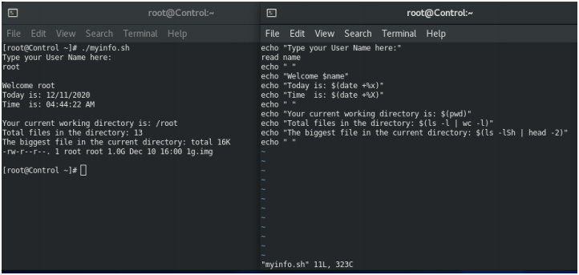

Assignment 1

Create a directory with a few test files in it (the files can be empty). Now write a script that for

every file in that directory you rename it to have an extension of today's date in YYYYMMDD

format.

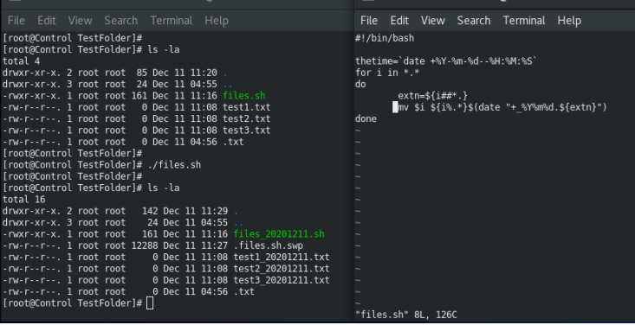

Assignment 2

Write a script that takes a number as an input and reverses it out to the user. For example, if the

original number is 74985, the output should be 58947.

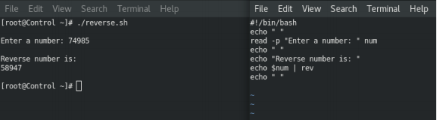

Assignment 3

Write a script to validate how secure someone's password is. Things you would care about: - Length should be 8 or more characters - The password should contain numbers and letters - There should be both uppercase and lowercase letters

